**ALY6000 - Intro to Analytics**

**Homework 1 – Week 1 – Use of R in Visual Studio Code**

Submitted to: Prof. Sergiy Shevchenko

Submitted by: Fuad Ali Khowaja

Date: 28th September 2023

1. **Installation of Visual Studio Code**

In order to install the Visual Studio Code we used a trusted website – Visual Code’s home website. Visual Studio Code works like an editor and IDE (integrated development environment) and is quite known for its cross-platform support. A snapshot of the Visual Studio Code is attached below:

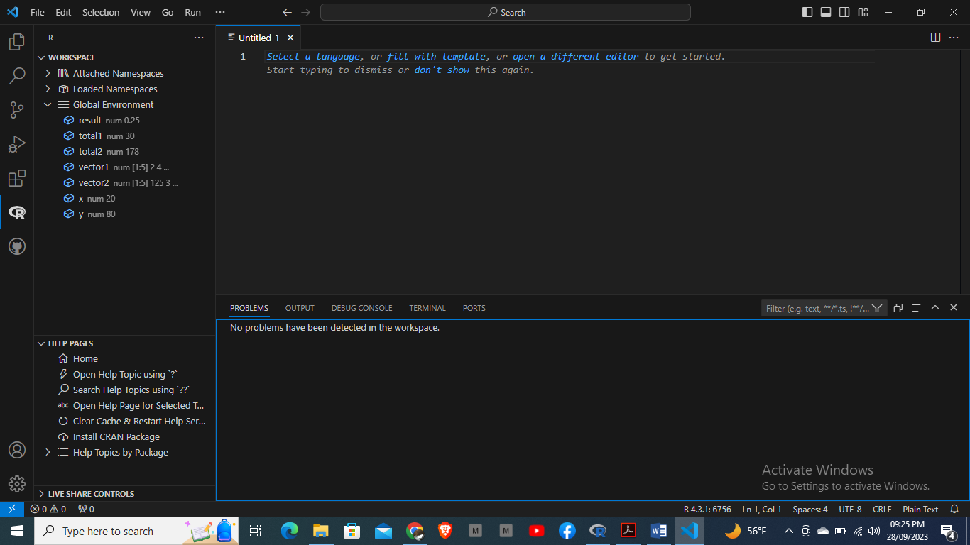

Source: <https://code.visualstudio.com/download>

1. **Install R as an extension in the Visual Code and set-up the packages**

There are two ways, either we can use the website to install it or another way is to just click on the extensions in the VSC and type R, it would automatically pull up the R extension and we can install it directly. In addition, with R we also need some packages such as “Radian” and “httpgd”. This can be done by typing: install.packages("httpgd") and pip3 install -U radian accordingly. Furthermore, we also need to install the library package as it is required for extending the R's capability and ease the work of data analyst to perform the analysis, statistical modelling, and many other tasks efficiently and effectively. Screenshot has been attached below for the reference:

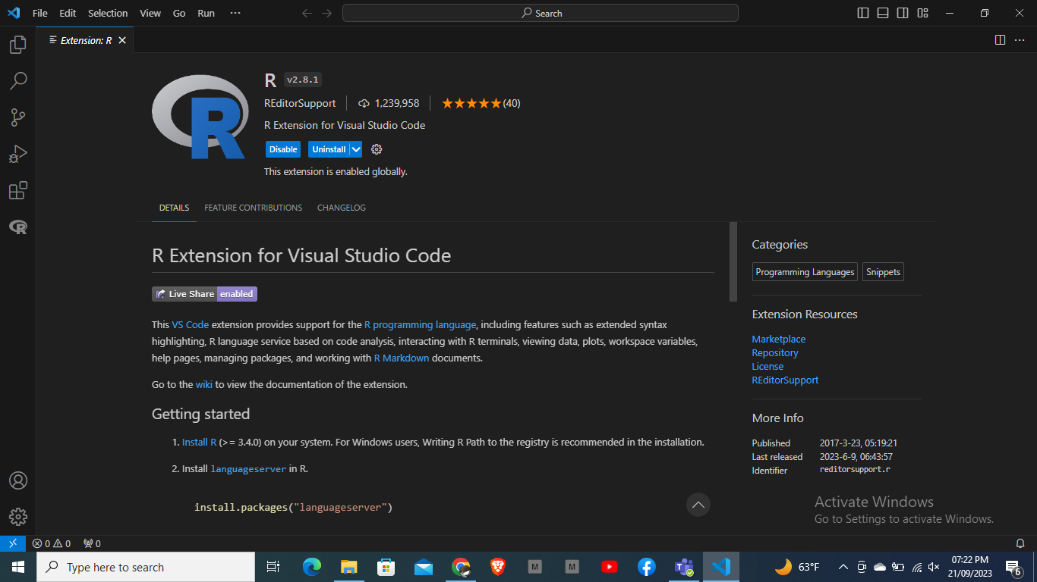

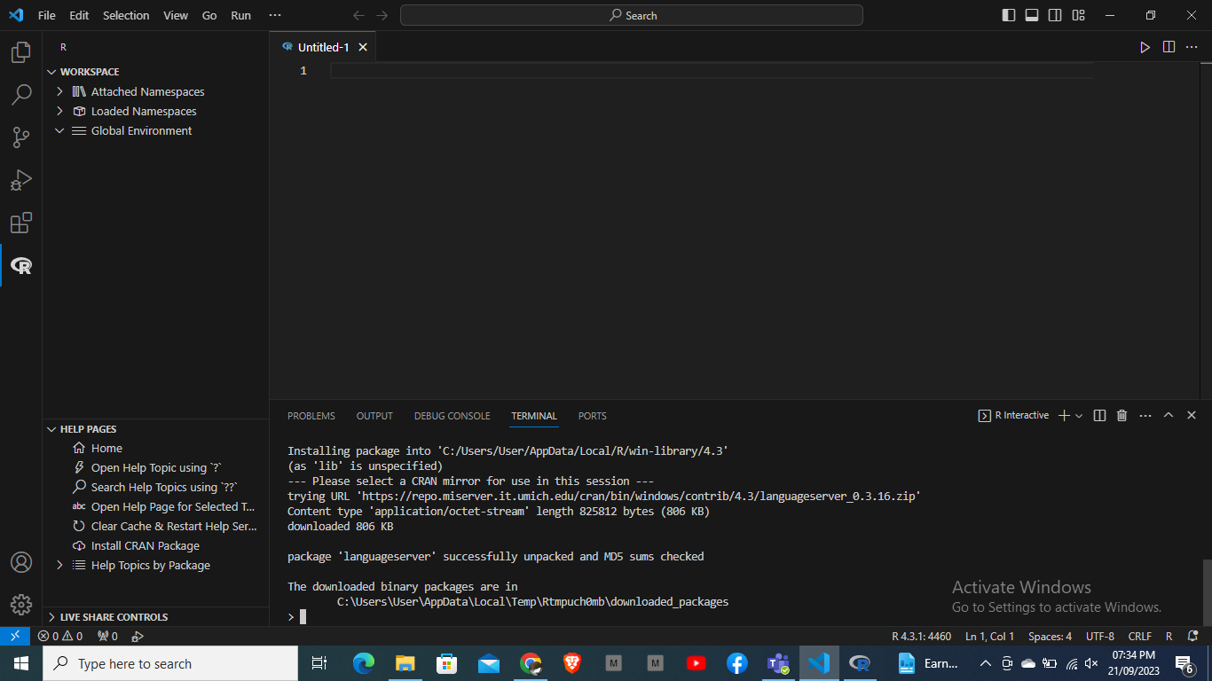

Source: adding extensions –

1. <https://marketplace.visualstudio.com/VSCode>
2. <https://code.visualstudio.com/docs/languages/r>

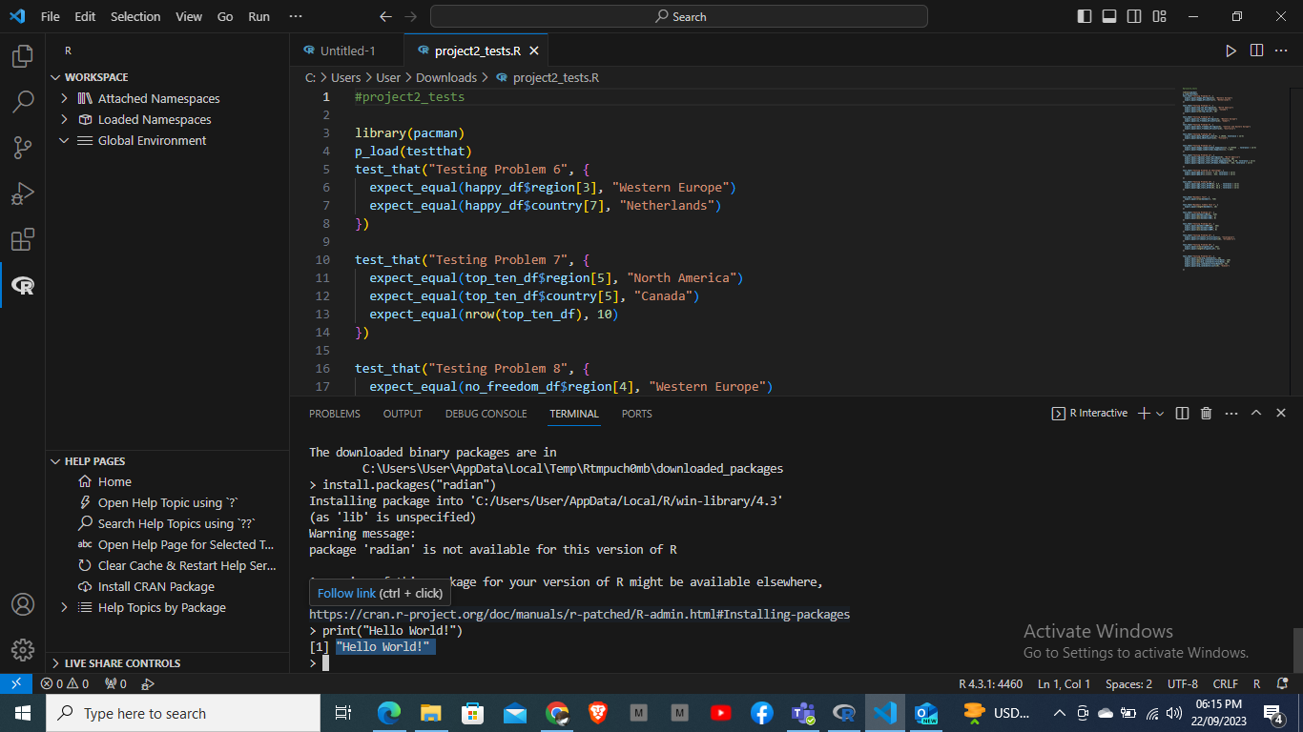

Source: Adding packages –

1. <https://github.com/randy3k/radian>
2. <https://github.com/nx10/httpgd>
3. **Using simple commands of R in the VSC**

Used the coding to add numbers as a single vector and write my name. I also assigned the numeric values to different names and used the C() function which is used for combining and concatenate the values or vectors together as a single vector. Screenshots are below for reference:

1. Assigning values to the names

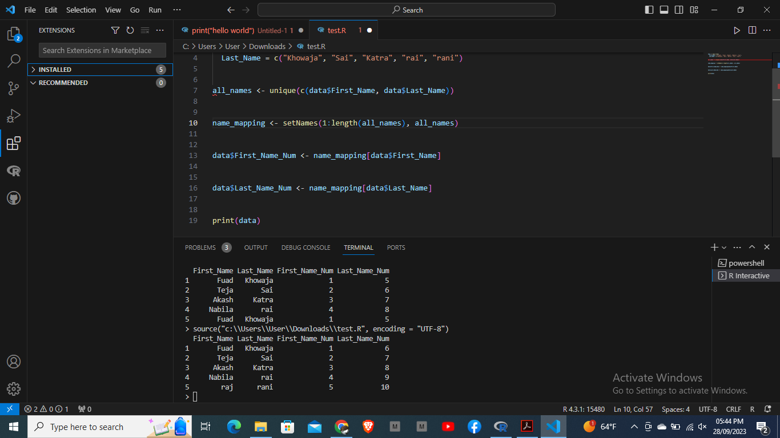

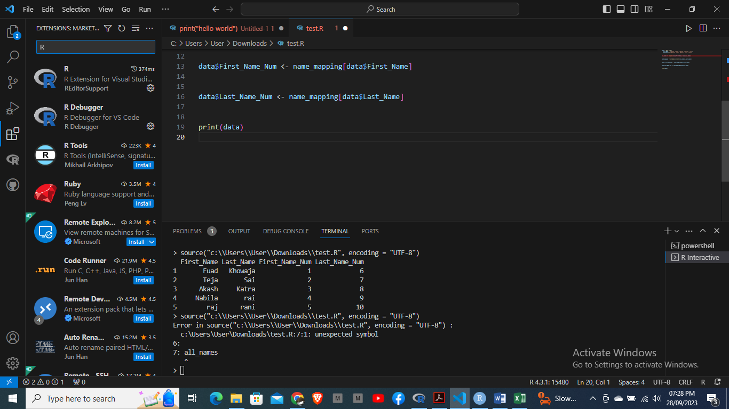

1. Sum of a single and multiple vectors and name functions

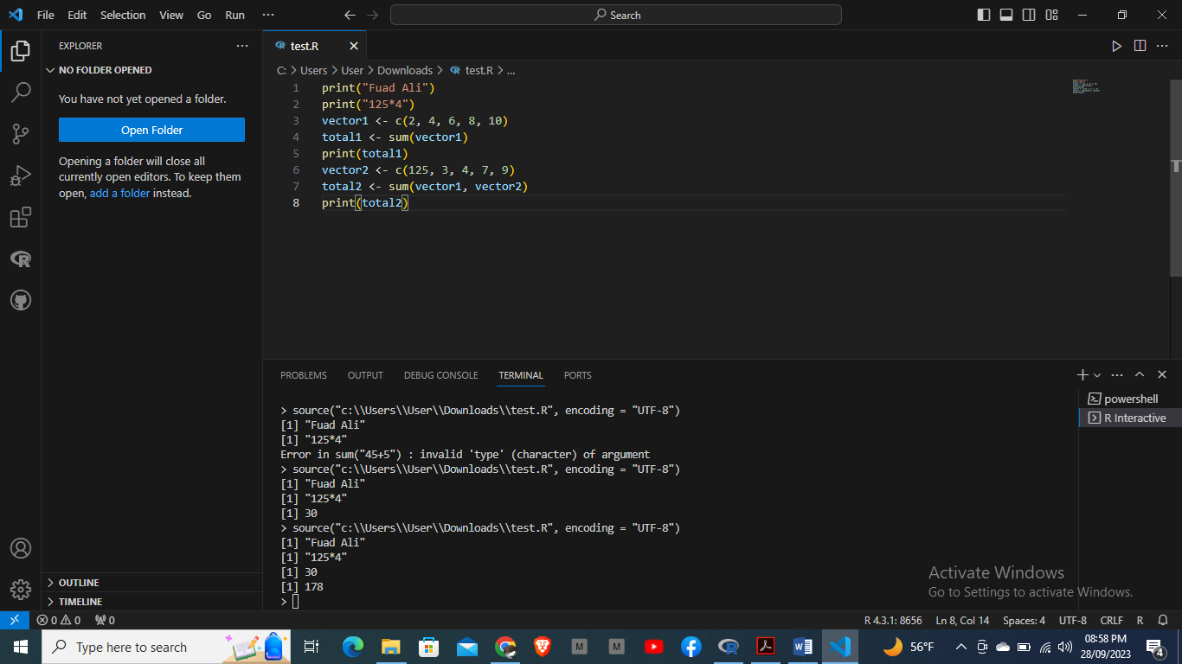

1. Multiplication operation with different values

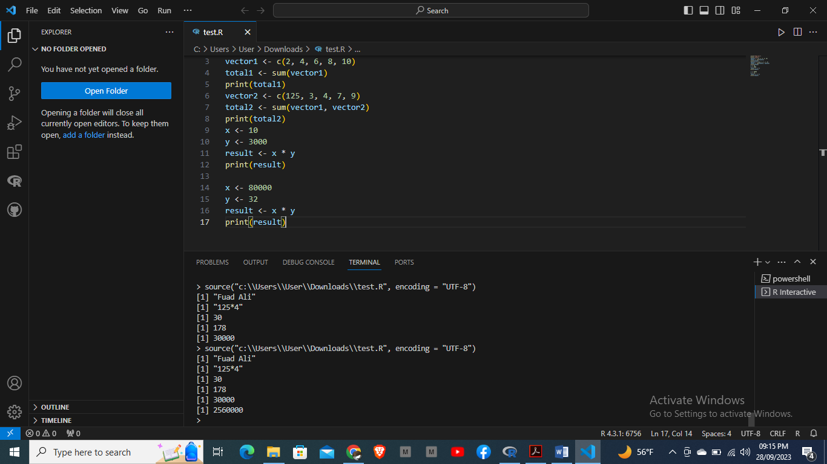

1. Use of divide function with different values

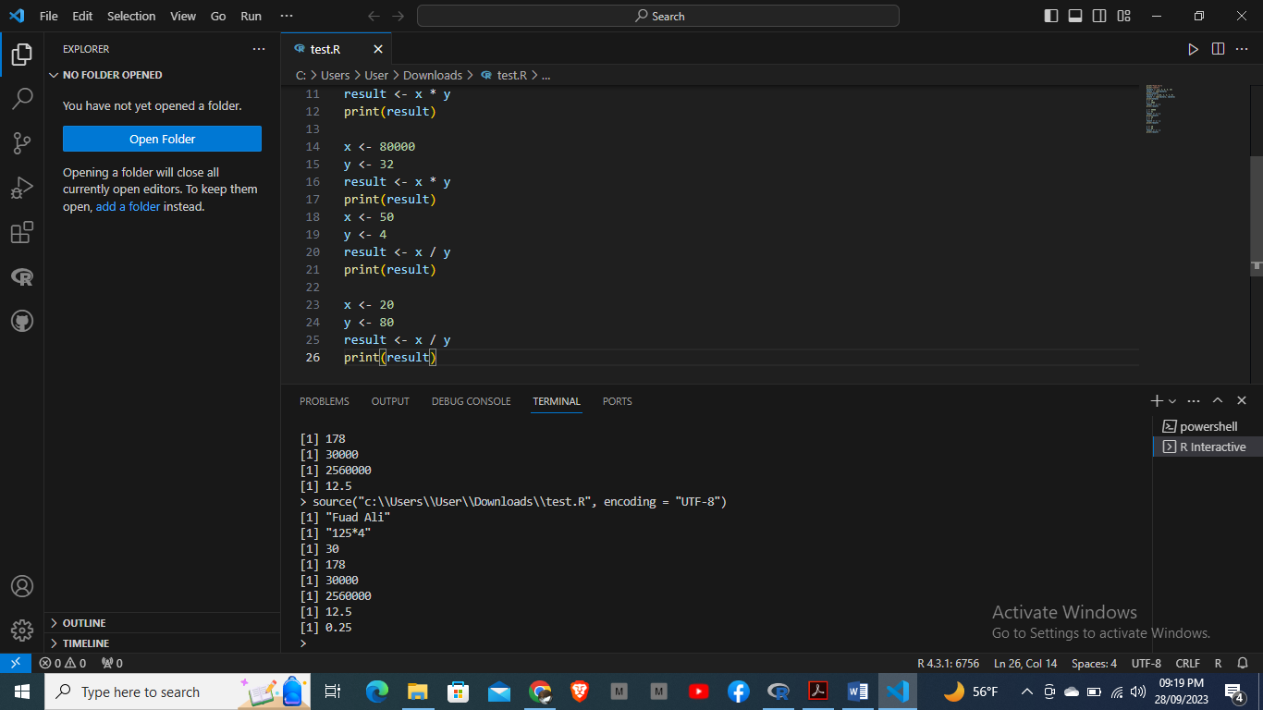

1. **Creating a Git-Hub account**

Part of the instructions for the homework is to upload the file in GitHub and share the link. So I created a fresh account as I had never used it before. Please see the screenshot below of the profile:



Link to GitHub:

The assignment has also been saved on the GitHub as a repository and link has been shared for accessing it.